Douglas County Cooperative Weeds Management Area
Oak Habitat & Rangeland Sub-Committee Meeting
January 22nd, 2024 - Meeting Minutes

*Attendees:
Maggie Begoun (DSWCD), Ryan Kay (BLM), Gerald Briggs (DCWAB), Steve Wickham (DCWAB), Amy Darr (ODFW), Marnie Keller (Cow Creek Tribe), Wade Christensen (Cow Creek Tribe), David Ferguson (NRCS), Steve Denney (UOP), Eric Riley (PacificBirds), Bryan Nelson (LRT), Mike Hennemen (True North NRC), Allison Manwaring (USFWS), Cindy Bright (DSWCD), Carri Pirosko (ODA), Eric Stauder (Oregon Conservation Corps), Nathan Jackson (Cow Creek Tribe), Katie Walsh (USFS), Brittany Oxford (ODF), Courtney Gattuso (WIN), Sam Friedman (USFWS), Lee Russell (ECWC), Matt Beach (ODF), Tracy Pope (Douglas County), Kathy Love, Paul Heberling

Introduction (Begoun)
Welcome: Maggie Begoun welcomes attendees to the meeting and explains that this is the first sub-committee meeting of the Douglas County Cooperative Weeds Management Area (DC-CWMA). The Oak & Rangeland CWMA sub-committee is a meeting to share among stakeholders what types of weed treatment projects are happening in DC and where there may be a need to collaborate.
How we got here: The DC-CWMA was restarted in spring of 2023, where it was ultimately decided among partners that they want the meetings to focus on project collaboration (rather than educational workshops, public outreach, etc.). After fall 2023’s DC-CWMA meeting, it was decided that the members would like to split into sub-committees to work on more specific projects (oak habitat vs urban vs riparian).
MOU & Funding: There is MOU Declaration of Cooperation (DOC) from 2010 that all the agencies in attendance signed to work towards the common goal of weeds management across the county. Begoun will be working with Courtney Gattuso from the Western Invasive Network to get a Memorandum of Underation (MOU) for the CWMA soon. Additionally, Begoun is not explicitly being funded to work on the CWMA so she has begun working with Ryan Kay at the BLM on a Good Neighbor Authority Agreement to provide funding for her time both coordinating and managing projects resulting from the CWMA.
Rangeland / Oak Habitat: Begoun notes that oak habitat includes rangeland primarily managed by private landowners and that as the representative for DSWCD, Begoun would be the primary liaison for private landowners on resulting weed treatment projects in this CWMA. DSWCD is non-regulatory and often serves as a trusted organization to help agencies collaborate with private landowners.
Current Oak Work (Denney, Ferguson, Riley)
Umpqua Oak Partnership: Denney explains that they are currently developing their strategic 5-year plan. The partnership has identified four priority areas where they want to focus their restoration efforts. The areas are somewhat centered around Oakland, Myrtle Creek West, North Bank, and the Upper South Umpqua.
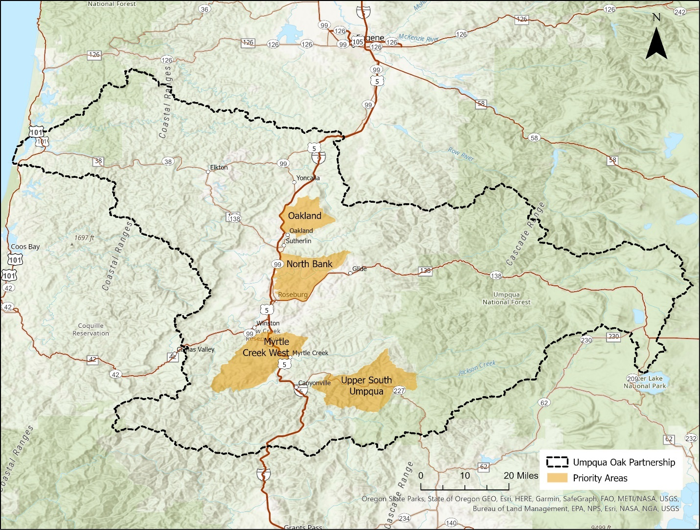
The partnership has identified secondary areas as well that may be included in the next strategic plan out HWY 42 and centered around Elkton. UOP had sent out surveys to over 1000 landowners throughout Douglas County to gauge their interest in oak habitat restoration. Of the ones who replied, the biggest takeaway was that landowners desired more education about oaks, wanted to see a successful restoration firsthand, funding opportunities, and technical expertise. A good number of the landowners recognized the need for prescribed fires as well but again, worried about the liability and lack of expertise surrounding the associated activities.
UOP is working with fire entities such as DFPA and local fire districts to build capacity for the equipment and expertise that could support more prescribed fire on the landscape to protect against catastrophic wildfire. UOP is trying to figure out long term funding to help be a resource for landowners in these areas that want to do oak habitat restoration work. Most of the oak in Douglas County is on private land. Denney spent 6 months meeting with the major landowner groups in the county and there seemed to be a lot of interest.
The main threats that were identified that have to do with the CWMA are invasive species encroachment (such as English hawthorn, blackberry, Scotch broom) as well as conifer encroachment. Landowners have recognized the loss of south facing conifers due to insects or drought.
Question: Has yellow starthistle been identified as an issue in oak habitat? I’ve noticed it in the North Bank area*
Answer (Denney): UOP has not created a specific list. The three that I mentioned are the prevailing ones that are easy to see, but there are many other invasives species damaging oak habitat.
Note from Begoun: I believe yellow starthistle can be found in all four oak habitat focus areas. May be worth the effort to take more notice of it when working in those area so that in can be incorporated into treatment efforts.

Natural Resource Conservation Service / Regional Conservation Partnership Program:
(The Smaller Scale) EQIP Activities - Ferguson explains that NRCS Roseburg Office has implemented 3-4 years’ worth of primarily hawthorn, blackberry, and a couple other weed control efforts for the sake of oak habitat on private land through the Environmental Quality Incentives Program (EQIP). Through brush management and stand improvement efforts with pile burning has been capturing most of the restoration efforts in oak habitat for NRCS. EQIP programs tend to fund up to 3 years of these activities. The EQIP has been focusing on only North Bank and Oakland’s focus area zones so far. There has been some luck with blackberry mow – spray – mow treatments. Medusa-head rye is becoming a problem in the area and NRCS is now looking at prescribed fire as a long-term maintenance tool for smaller annual invasives. All of this is through a regular, annual funding cycle.
(The Larger Scale): RCPP Activities - Through partnership with UOP, NRCS is hoping to increase the pay and scale of these activities, however. They’d like to get into the other focus areas and build capacity by getting a national funding source for the county through the Regional Conservation Partnership Program (RCPP). This would be an ask of $5-10 million for a 5-year period, which isn’t that much relative to what USDA has.
There is about a 30-40% match component to this grant. Basically, any participating stakeholder in the area would tell the RCPP what they’re planning to spend on oak habitat restoration in Douglas County in the next 5 years (no contract or risk as they are not held to their match offer by contract) and that would be used as match to demonstrate that partners are working toward a common conservation goal but need to build capacity.
Additionally, USDA is now mostly in support of “climate-smart” activities now. This could be argued as almost any activity though: thinning, weed treatments, soil monitoring, etc.
Question: Do RCPP partner activities need to be labelled as “climate-smart?”
Answer (Ferguson): No, that’s not required. However, the recent $20 billion that come to the USDA by this administration is designated for “climate-smart” activities so it would be wise to spin it that way. The list of activities is actually very long and encompasses a lot of different departments. It’s also worth noting that with a potentially new administration next year, this could all change. But if a RCPP is created now, that money should be able to stay with it.
Example of recent RCPP: Sustainable Northwest got RCPP funding to wildfire recovery activities with the Archie Creek Fire Area. NRCS Roseburg has nothing to do with it as it’s a national funding source that’s being applied for by local organizations.
Question: Is there any effort being made toward regeneration of oaks? There is a huge gap in oak generations and their young survivability. It would be nice to have technical assistance from someone who knows about oaks habitat visit private lands.
Answer (Ferguson): NRCS is focused on the big, upfront heavy lifts of oak restoration. There is a thought that prescribed fire might be the way to help regeneration. Under this administration, a higher priority is to increase native biomass so oak regeneration has the potential to be a key goal in the RCPP. However, the entire picture must be taken into account including maintenance plans and weed treatments.
(Begoun): While native plants are an obvious part of the entire restoration goals, this partnership meeting is focused on the invasive species aspect. The follow up to weed treatment will naturally be to get Umpqua Native Plant Partnership or OSU Ext. involved to get native trees, plants, shrubs out to help restore habitat but also be used as a tool to compete with invasives as well.
(Denney): Some research shows that fire stimulates acorn production. There would be multifaceted benefits to each of the potential activities being offered by NRCS/UOP/RCPP.

Previously Expressed Project Interests (Begoun)
Begoun explains that over the past year, she has heard a couple of different ideas for projects that would address a need in Douglas County weed management.
1) NRCS has been interested in developing a follow-up maintenance program that helps landowners enrolled in EQIP continue to receive technical assistance, monitoring, and potentially funding from elsewhere to make sure that restoration goals are continuing to get met and not falling off as soon as NRCS’s contracts expire.
2) Creation of an English hawthorn specific CWMA that targets a certain area in need and helps facilitate treatment across all jurisdictional boundaries within the area. This is similar to the Cox Creek Portuguese broom CWMA, where Elk Creek Watershed Council applies for money and manages a project that helps treat Portuguese broom on private land, timber land, and BLM land up in Yoncalla area. For a Hawthorne CWMA, we could create one within an oak focus area as already outlined.
3) Firewise USA Community CWMAs. Landowners who want to have a Firewise community can have more incentive to create them with CWMAs that help those landowners do weed treatments in those communities.
(Denney): There may be a huge backlog of applicants, but once a Firewise community is approved then they can apply for funds to do limbing, brushing and clearing around structures.
Many local volunteer fire departments are actually applying for large grants that would serve larger areas than a fire-wise community. Lookingglass Fire Department applied for a grant to do fire-wising for landowners between Colonial Ridge and San Souci. If there is interest, a project could be developed in conjunction with these fire department’s fire-wising projects that is more coordinated than the current piecemeal approach.
(Nelson): DFPA has an active winter crew that does fire-wise activities in the winter and is working through the backlog of applications. They are mostly slashing, not sure if prescribed burning is part of these activities.
Oregon Conservation Corps (OCC) also got a large grant from the Fire Marshall to do winter fire-wising work. It might be worth working to get a weeds crew that follows their fire-wising work.
4) Rare plant habitat CWMAs that could focus on weed treatments to enhance rare plant survival associated with oaks in the region. Creating CWMAs that surround entire oak habitats across jurisdictional boundaries with the intention to treat weeds in the entire area to help sustain rare plants.

Open Discussion
(Begoun) invites the group to talk about any other interests they may have in project creation and collaboration.
Maintenance Needed
(Denney) notes that maintenance is a key issue with projects. The group should try to keep maintenance dollars in the budget for at least here years to continue necessary follow-up treatments.
Conifer Encroachment & Monitoring Need
(Love) brings up that in the past she had an NRCS project to fence off her creek and replant the riparian area that extended into oak savannah. She argued with NRCS that she didn’t want to plan trees in her oak savannah but they threatened to take away funding if she didn’t. Now there are trees in her oak savannah that she’s going to have to take out, it was useless.
(Briggs) Yes, so what is wanted for the end result in oak restoration? Many of the NRCS activities just create new problems.
(Ferguson) Every plan is site specific. If the land hasn’t been managed in 50 years, the goals for that property are going to be different than someone who has kept up with some management each year. A big issue we are facing right now is that landowners are getting up there in age and aren’t able to keep on the work needed for some of the goals planned for their property.
(Bright) Is monitoring fundable in the RCPP? Monitoring would help bring issues to landowners’ attention that they may not be able to get out and see.
(Ferguson) No, it’s not. USDA’s really going to want to see an entire plan of treatment and a lot of the how’s and why’s for the RCPP. Monitoring would need to come from another source.
(Keller) I’ve noticed that some of the younger oaks are actually growing faster in the shade of the conifers instead of getting roasted. Once they get to a size where they are competing, it would be time to get rid of the conifers.
(Bright) Part of this may also be the communication between root systems of the existing trees. There is a dripline where it is ideal to start growing baby trees.

Monitoring / Self-Reporting
(Begoun) So far, I am hearing that monitoring and maintenance are big issues. Are these things that you guys think you need for existing projects? Should there be a separate program to follow up on projects that are already ongoing? Such as NRCS, and maybe BLM? There could be a county-wide oak habitat monitoring program.
(Riley) Traditionally, monitor funding for any natural resource project is incredibly hard to get. I wonder if a self-reporting system may be more sustainable.
(Pirosko) Monitoring and maintenance is always hard to fund. Usually, grants don’t look that far into the future. As far as self-reporting, many organizations across the state have herbicide cost-share programs that require landowners to collect and contribute data on what weeds are being treated where and when. More successful models usually include partnering with agencies like NRCS or BLM where they have staff or capacity to get quality monitoring done.
One role instead of monitoring that the CWMA can serve along with ODA, DSWCD, and DCWAB, can be to have the right tools in place to help land managers control invasive species. The CWMA can help analyze what tools are currently being used for treatment in Douglas County and decide whether they are effective or not. There are many new herbicides that private landowners may need some education and help with. This would help lower the need for monitoring.
(Darr) ODFW has a tax incentive program that requires annual reports submitted by landowners. It has been a mixed bag from issues with both the agency and landowners. Sometimes it’s just because the landowners weren’t very invested and didn’t pay much attention to details. Other times it’s the format of the report from ODFW that isn’t very intuitive. Sometimes landowners just give up on trying to report because they don’t know who to contact for help and haven’t had any follow up. Having a dedicated platform where landowners can self-report and a built-in system that reminds them to annually would be super helpful for data collection.
(Kay) The BLM does have a self-guided monitoring program with standards they’ve created that is available for anyone to use. The CWMA could look into doing training for land managers and landowners on it.
(Bright) ODA has a vegetation monitoring standard as well.
CWMAs
(Begoun) Is there interest in any of the project ideas that have already been brought up? There are four identified areas in front of you that encompass private land, BLM, tribal, USFS, and more that could be collaboratively worked on within the boundaries.
(Kay) What’s the value in having separate, smaller CWMAs instead of doing projects under the umbrella of the county-wide CWMA?
(Begoun) Mostly specific project funding and being able to show that all these partners are contributing resources to a smaller, more manageable area. For example, the Oregon State Weeds Board usually helps fund the Cox Creek CWMA because it’s a manageable area, with a solid goal, and key partners that pretty manage the entirety of the area. Smaller scale is usually easier with funding.
(Denney) It’s the same approach that UOP was doing when creating these four oak habitats focus areas. These are subject to change with new management goals of course.
(Kay): It’s helpful to have smaller priority areas to focus on for land management goals as opposed to going after say, all the blackberry in county which isn’t achievable.
(Bright) When the next Private Forest Accord funding opens, it might be worth looking into funding a CWMA. Additionally, the PFA funding that I applied for recently is for our Strategic Implementation Area which completely overlaps with the “Upper South Umpqua” focus area and may be able to be used as match for other projects going on there. PFA activities do have to relate to benefiting aquatic species though.

Availability of Labor / H2B / OCC
(Nelson) Has anyone had labor issues to carry out projects? Making sure there is available labor for the CWMA projects is necessary and may not be that difficult. For example, many of my contractors don’t have much work once the trees are planted. Maybe the same way the DFPA starts going down their fire-wising backlog of work in the winter, these contractors can be set up for winter work doing something similar. There has been an increase in the H2B guest workers in the area and contractors have guaranteed them 9 months or so of work. There should be a connection between these contractors and other agencies so that anytime they run out of work, they can switch over to something else. This could be hand crew, herbicide crew, thinning, etc. The availability of local workers is super low. All but maybe one of my contractors is exclusively H2B and they mostly charge by the hour. If there could be a list of projects that these contractors can send their crews to whenever they have time and a pot of money to pull from for that, it would work great.
(Denney) We used to have a lot of OYCC/OCC crews do work throughout the county and were great source of labor. They could possibly attain the funding for monitoring as well because they tend to pull from a different funding source for youth/career training. Us older folks would love to have younger people out there working.
(Stauder) Our program with OYCC/OCC has 30 young people employed with a third of them being high school aged with no job experience. Our crux of capacity is centered on building leadership right now. We do have the capacity to take on more projects, but we are simultaneously trying to make sure that these young adults have the correct leadership guiding them through the career learning process. Some of them need to learn soft skills as well as hard skills. The adult crews with OCC are of a higher caliber and career training oriented. They have saw certifications and are typically doing fire-wise activities throughout the winter as well.
Overall, we are a work force training program. So we can provide labor, but we are doing so while training underserved youth some of the time and so our labor is better suited to compliment contract crews vs being a substitute for them.

Other Current Oak Restoration Projects on the Ground
(Begoun) Are there any actual projects going on at this moment?
(Kay) The BLM is working on a prescribed burn treatment for spring at North Bank Habitat Management Area. That will be followed up by weed treatments.
(Ferguson) There are many landowners throughout the Oakland and North Bank areas that are doing active restoration projects too. It can be difficult to find a contractor though to treat small acreage for private landowners.
(Manwaring) USFWS has a hand full of landowners doing the same. They are mostly within the focus area boundaries.
(Begoun) Do you guys see a need for cross-boundary coordination then? Are you seeing blackberries creep across the landscape to areas you can’t treat?
(Christensen) The tribe has been working on oak habitat on their land surrounded by USFS. They have removed a lot of conifers and are worried about what may fill in the newly bare land, most likely coming in from across boundaries.
(Begoun) That might be a prime area for completive planting and seeding.
(Christensen) We’ve put down some ODFW elk mix (which does have non-natives in it) and are now working on trying to keep the blackberries and Scotch broom out. We would like to initiate a burn program. The tribe has treated 600-800 acres of conifer and the USFS is thinning about twice that so they’re looking at collaboratively having prescribed burns throughout the entirety of the area.
(Keller) We are now trying to work with Umpqua Native Plant Partnership to get more native seed mixes too.
(Wickham) I take care of my oak woodland on my property all the time. Most of my conifers died out on their own. When I worked for Plum Creek on the coast, there were a lot of oak prairies with no oak regeneration. It may have been due to elk and cattle.
(Denney) My place has great oak regeneration, but I do have to fence the seedings from wildlife.

Outreach & Education
(Riley) A lot of landowners just want technical advice. They want visits to their property and to be told if they should thin an area or remove a certain weed. A lot of the time, they figure out how to do on their own.
(Darr) Did the UOP survey show that the landowners wanted just technical advice, or did they also want more access to workshops, physical/online resources, etc?
(Ferguson) There is a whole spectrum of people. Some people are old and need help. Other people have their construction crew and want to do their entire project in one week. But everyone desires more information/consultation.
(Hennemen) What does outreach look like in these are for smaller private landowners? You can usually do that initial push for landowners, but if their neighbors aren’t educated – it’s almost all useless.
(Ferguson) Neighbor to neighbor relationships are usually the best way to do outreach. Making sure one neighbor is getting the education they want and hoping they reach out to their neighbor.
(Denney) It is worth nothing that there are now a huge number of new landowners that have no intention of management and think that leaving it alone is the most natural thing to do. Getting more education out to those people is key too.
(Ferguson) Defensible space is a huge way to draw people in now. Rural fire districts are now going out and analyzing private land and basically advertising NRCS funded activities to landowners to create defensible space.

Next Steps
Keeping the line open between agencies and landowners is going to be key. Some agencies often have turnover and new staff need to be reminded about projects that border or even are within their jurisdiction. Even with the administration changes, the CWMA will be there to continue pushing local programs. As funding comes and goes too – the local partnership will be there to fill the gaps and communicate their needs.
I’d be happy to hear from any partner about the gaps in invasive pest management that you have identified and think the CWMAs can help fill. Please see the list below that Carri Pirosko and I put together and let me know what you think.

Needs:
- Support local grant writing efforts (NRCS-RCPP, ODF Urban Comm. Forestry Program, etc.)
- Support for landowner maintenance and monitoring post woody invasive plant removal.
- The “how to” in oak recruitment, regeneration (fencing as a tool, etc.)
- Landowner accessible technical advice (oaks, weeds, fire)
- Identification of local labor pools accessible to both private and public sectors
- Coordination effort toward uniting Rx burning/defensible space/weeds management.

Potential Actions:
- Partners write letters of support, calculate in-kind/cash matches for grant writing efforts. Oak restoration efforts in Douglas County can be matched with the potential USDA – RCPP funding the UOP will eventually go for.
- A few CWMA partners mentioned ways to do monitoring (ODFW, BLM simple protocols) and a few partners mentioned having current grant opportunity to write-in monitoring
  - Create a more easily accessible hub for self-reporting & monitoring in private lands
  - Have workshops on how to use them.
  - Potentially have an OCC monitor crew collect data
- Partner with local volunteer fire Depts and/or Douglas FPA: fuels reduction, including woody invasives (hawthorn, blackberry, Scotch broom)
- Develop a list of ongoing oak restoration projects (for fire safe, youth or other crews available in the area; to collate many smaller projects making they more attractive to contractors)
  - Find a way to make list/funds available to H2B contract crews so they can work on projects in their “off” time.
  - Find a way to flip landowners over to DSWCD for post-NRCS project monitoring and maintenance.
- Sponsor a joint oak partnership/CWMA workshop for landowners. Workshop focus: woody invasive control toolbox, oak regeneration, landowner friendly monitoring/maintenance protocols. Make sure landowners and land managers have the appropriate toolbox as to reduce a need for ongoing maintenance
- Perhaps a roving team of technical experts (noxious weed, fire, oak expertise) to visit potential project landowners.
- Create an up-to-date labor pool list with contact and service information.
- Create an up-to-date resource regarding successful weed management techniques.

ODF = Oregon Dept. of Forestry
ODFW = Oregon Dept. of Fish & Wildlife
NRCS = Natural Resource Conservation Service
ODA = Oregon Dept. of Agriculture
USDA = US Dept. of Agriculture
USFS = US Forest Service
DSWCD = Douglas Soil & Water Conservation District
DCWAB = Douglas County Weeds Advisory Board
USFWS = US Fish & Wildlife Service
LRT = Lone Rock Timber
BLM = Bureau of Land Management
ECWC = Elk Creek Watershed Council
RCPP = Regional Conservation Partnership Program
UOP = Umpqua Oak Partnership
O(Y)CC = Oregon (Youth) Conservation Corps
CWMA = Cooperative Weeds Management Area
DFPA = Douglas Forest Protection Agency
MOU = Memorandum of Understanding

